Los gustos de mi familia y yo
Para: el jueves 10/2
In this proyectito you will talk about your likes and dislikes as well as those of someone in your family. In your mini-project you must:
- Discuss 5 of your likes/dislikes.
- Discuss 5 of your family member’s likes/dislikes.
- Discuss 5 of your mutual likes/dislikes.
- Include phrases from the Ultimate Formula in your gustar notes.
- Include vocabulary from Chapter 1A (you may not repeat verbs—there are 21 verbs for you to choose from).
- You must include 2 illustrations of the likes/dislikes in each column. Structure your final product based off of the example below. Remember, you still need two pictures and five sentences in each column!
- Use the title above as the title of your final product.
- You will be graded off of the Spanish classwork rubric.
Helpful vocabulary:

el padre
la madre
el hermano
la hermana
el primo
la prima
el abuelo
la abuela
el tío
la tía
A mí | A mi ____________ | A nosotros(-as)
(+) A mí me gusta montar a caballo.  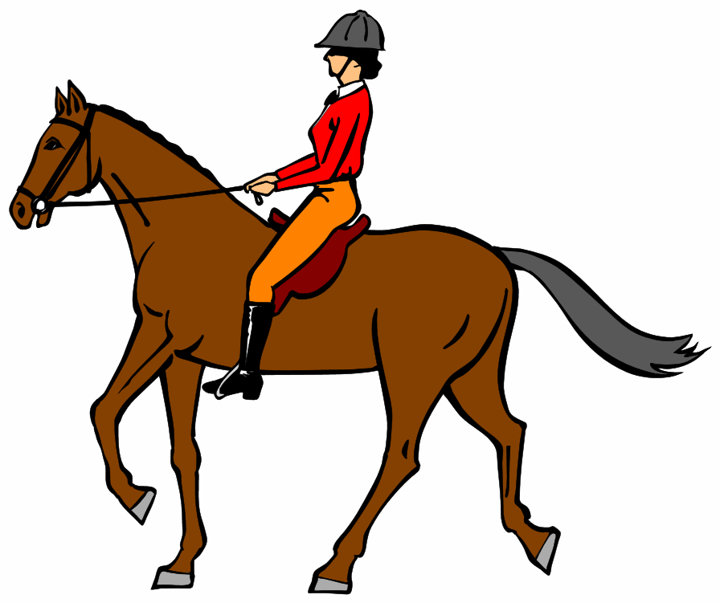 | (-) A mi madre no le gusta nada cocinar. | (+) A nosotros(-as) nos gusta mucho viajar.

